SCRIPTED PIPELINE
Setup a Jenkins CICD pipeline using Scripted pipeline using feature-1.1 branch. https://github.com/betawins/sabear_simplecutomerapp/tree/feature-1.1
stages:
Git Clone
node {

stage('Checkout') {
echo "Checking out source code from Git..."
git branch: 'master',
url: 'https://github.com/pmohd6065-ux/sabear_simplecutomerapp.git'
}
}
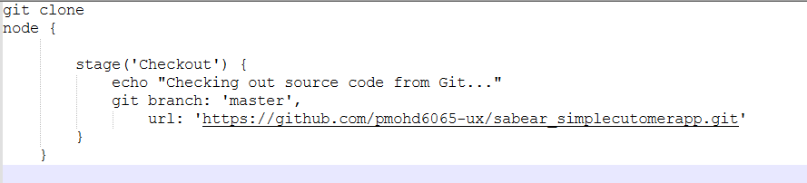
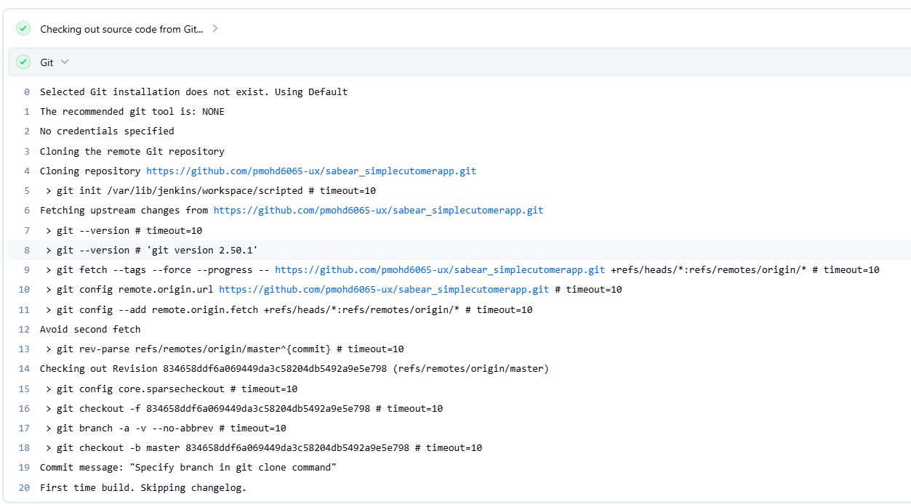

Maven Compilation
node {
// Define Maven environment
def mvnHome = tool 'MVN_HOME'

stage('Checkout') {
echo "Checking out source code from Git..."
git branch: 'master',
url: 'https://github.com/pmohd6065-ux/sabear_simplecutomerapp.git'
}

stage('Build') {
echo "Running Maven build..."
sh "${mvnHome}/bin/mvn clean install -f pom.xml"
}
}

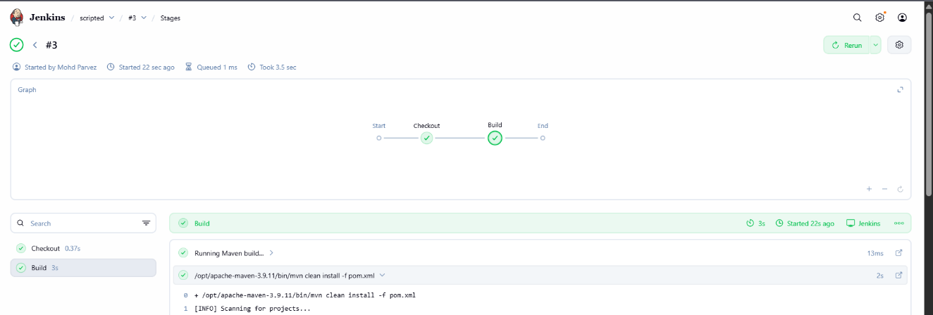

SonarQube Integration
node {
def mvnHome = tool 'MVN_HOME'

stage('Checkout') {
git branch: 'master',
url: 'https://github.com/pmohd6065-ux/sabear_simplecutomerapp.git'
}

stage('Build') {
sh "${mvnHome}/bin/mvn clean install -f pom.xml"
}

stage('SonarQubeAnalysis') {
withSonarQubeEnv('SonarQube') {
sh "${mvnHome}/bin/mvn sonar:sonar"
}
}
}

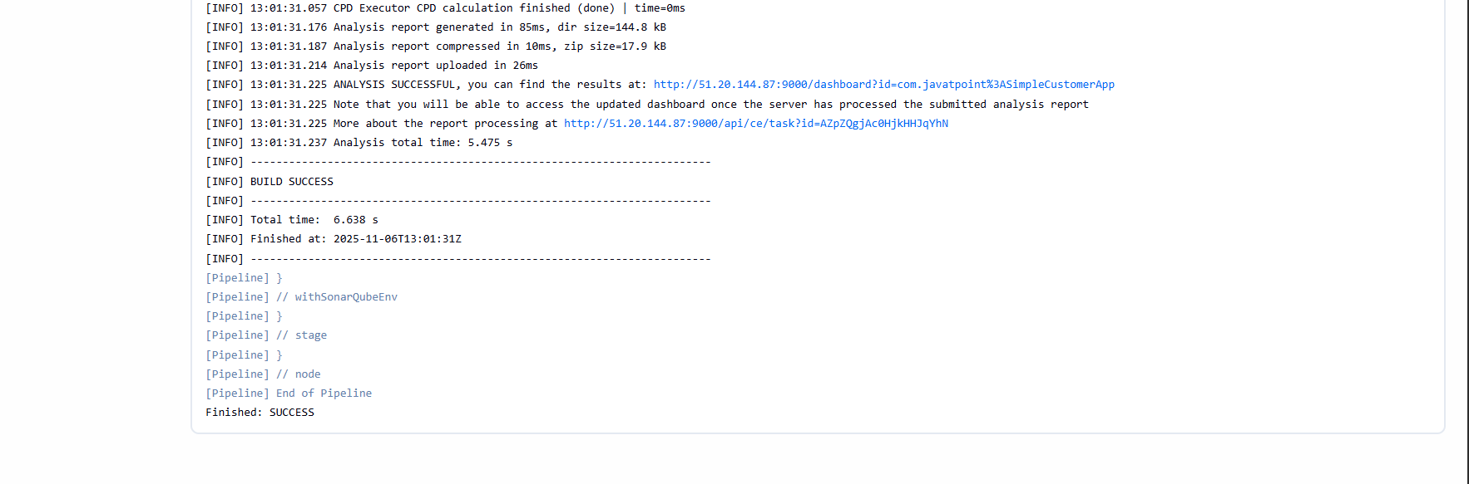
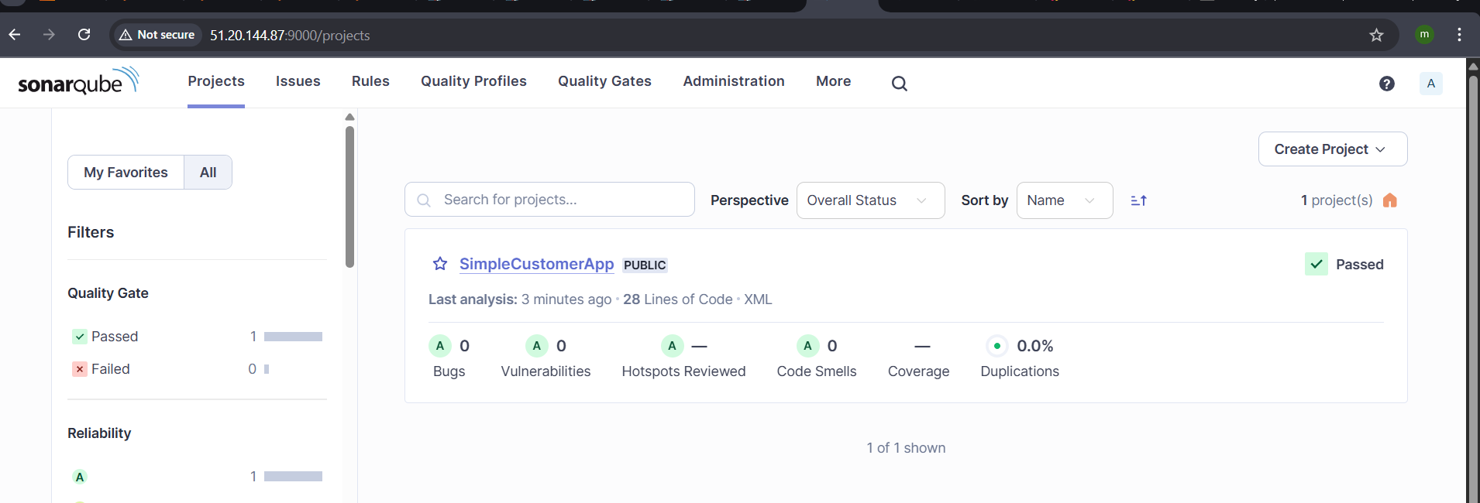
Nexus Artifactory
node {
def mvnHome = tool 'MVN_HOME'

stage('Checkout') {
git branch: 'master',
url: 'https://github.com/pmohd6065-ux/sabear_simplecutomerapp.git'
}

stage('Build') {
sh "${mvnHome}/bin/mvn clean install -f pom.xml"
}

stage('SonarQubeAnalysis') {
withSonarQubeEnv('SonarQube') {
sh "${mvnHome}/bin/mvn sonar:sonar"
}
}
stage('Upload to Nexus') {
nexusArtifactUploader(
artifacts: [[
artifactId: 'SimpleCustomerApp',
classifier: '',
file: "target/SimpleCustomerApp-${env.BUILD_NUMBER}-SNAPSHOT.war",
type: 'war'
]],
credentialsId: 'nexus',
groupId: 'com.javatpoint',
nexusUrl: '13.49.224.44:8081',
nexusVersion: 'nexus3',
protocol: 'http',
repository: 'feature',
version: "${env.BUILD_NUMBER}-SNAPSHOT"
)
}
}
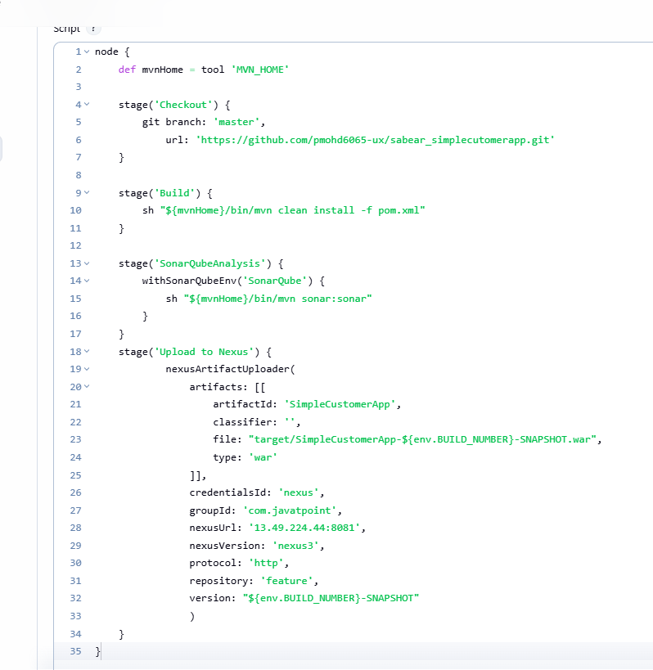
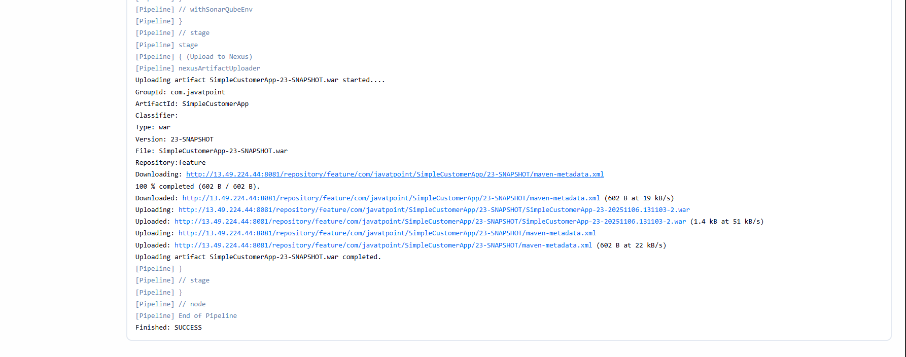
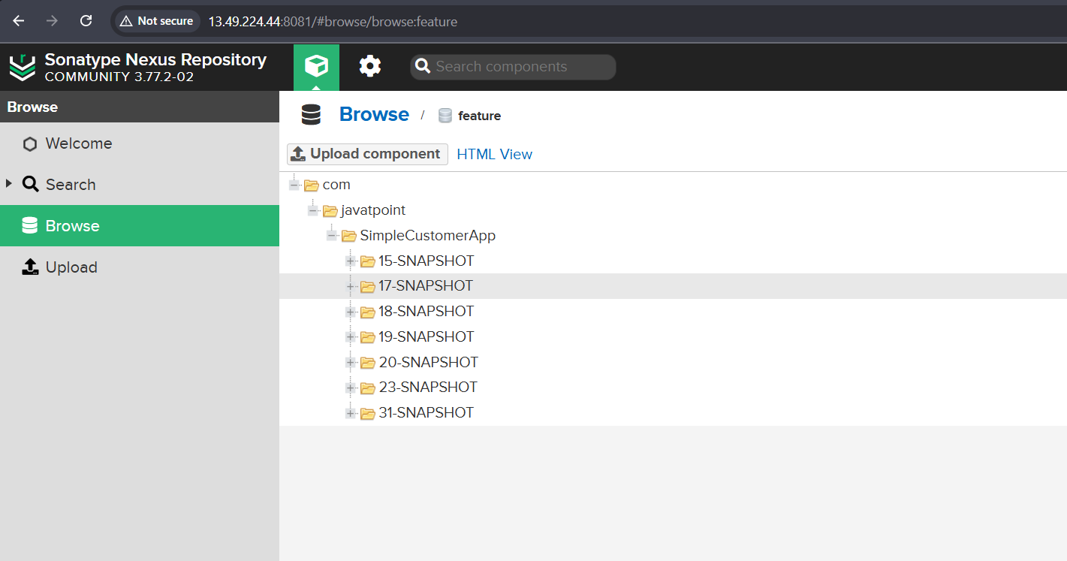
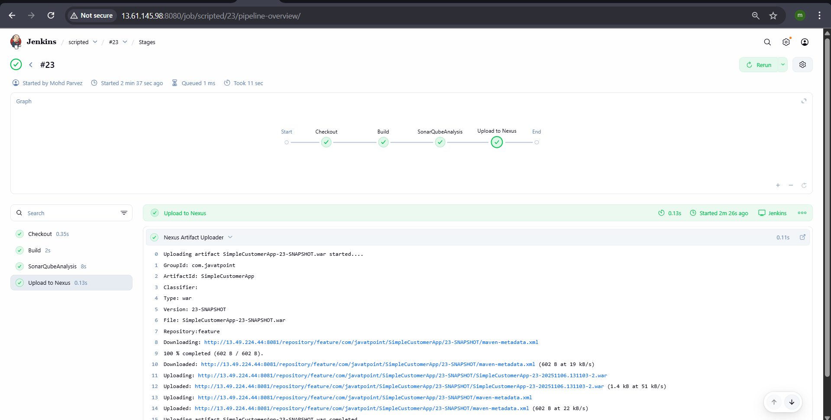

Deploy on tomcat
node {
def mvnHome = tool 'MVN_HOME'

stage('Checkout') {
git branch: 'master',
url: 'https://github.com/pmohd6065-ux/sabear_simplecutomerapp.git'
}

stage('Build') {
sh "${mvnHome}/bin/mvn clean package -f pom.xml"
}

stage('SonarQube Analysis') {
withSonarQubeEnv('SonarQube') {
sh "${mvnHome}/bin/mvn org.sonarsource.scanner.maven:sonar-maven-plugin:4.0.0.4121:sonar"
}
}

stage('Upload to Nexus') {
nexusArtifactUploader(
artifacts: [[
artifactId: 'SimpleCustomerApp',
classifier: '',
file: "target/SimpleCustomerApp-${env.BUILD_NUMBER}-SNAPSHOT.war",
type: 'war'
]],
credentialsId: 'nexus-server',
groupId: 'com.javatpoint',
nexusUrl: '13.51.159.64:8081',
nexusVersion: 'nexus3',
protocol: 'http',
repository: 'feature',
version: "${env.BUILD_NUMBER}-SNAPSHOT"
)
}
stage("Tomcat") {
deploy adapters: [tomcat9(alternativeDeploymentContext: '',
credentialsId: 'tomcat',
path: '', url: 'http://13.61.6.206:8080')],
contextPath: null,
war: '**/*.war'
}
}

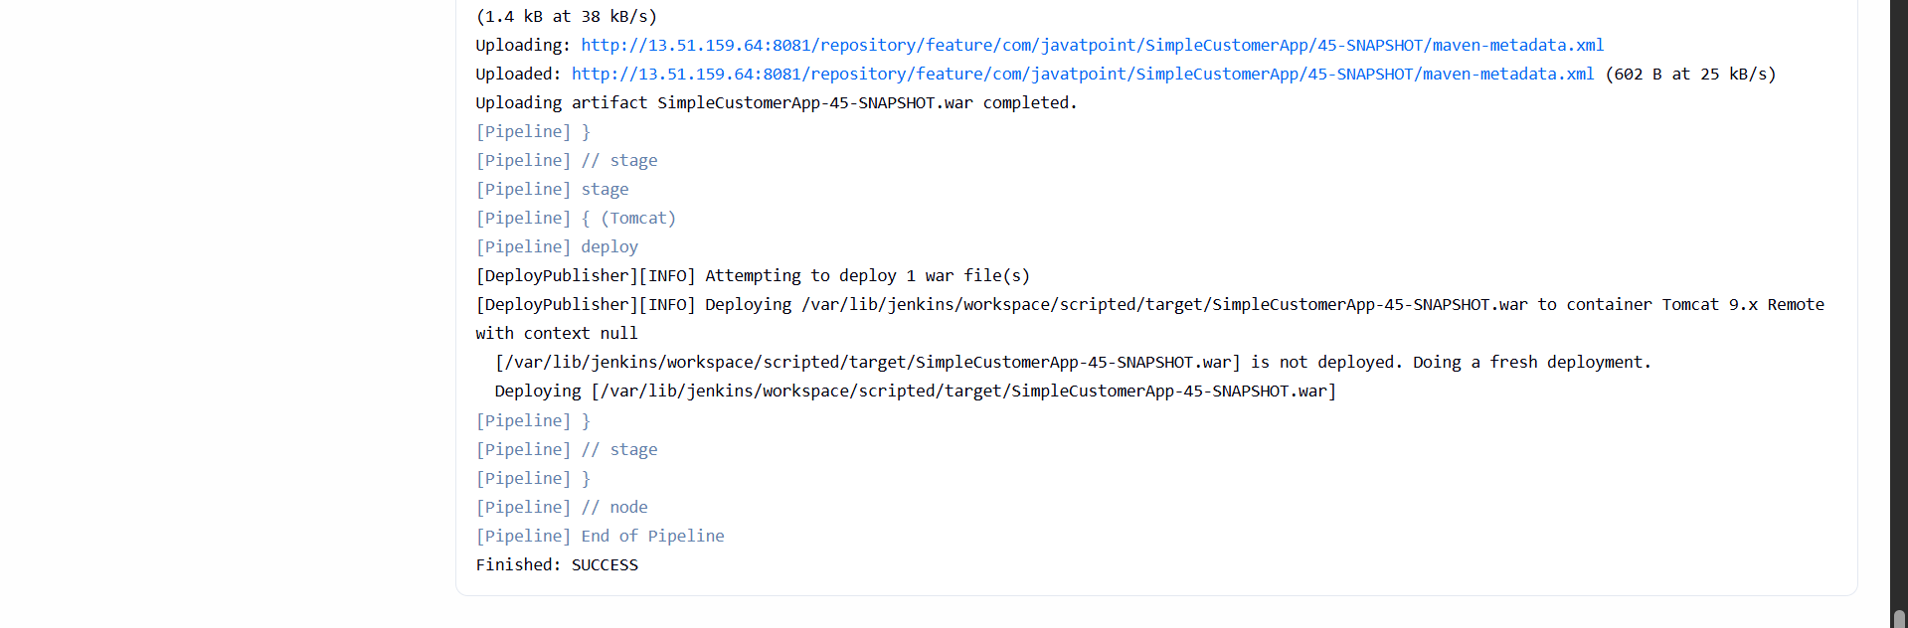
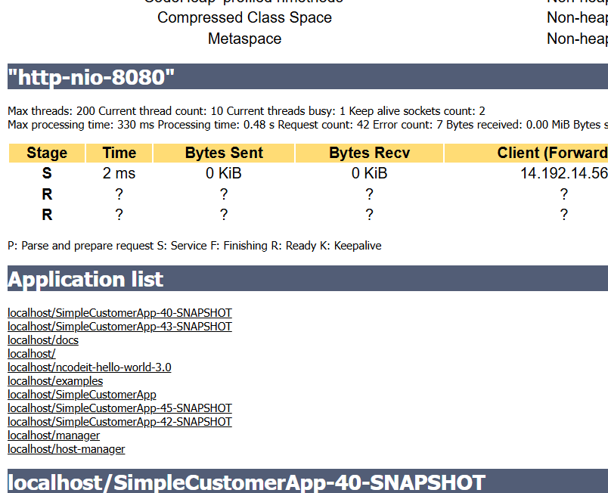
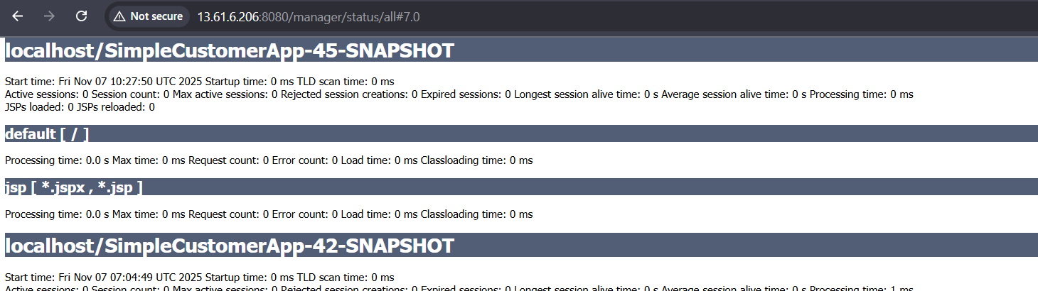

Slack Notification
node {
def mvnHome = tool 'MVN_HOME'

stage('Checkout') {
git branch: 'master',
url: 'https://github.com/pmohd6065-ux/sabear_simplecutomerapp.git'
}

stage('Build') {
sh "${mvnHome}/bin/mvn clean package -f pom.xml"
}

stage('SonarQube Analysis') {
withSonarQubeEnv('SonarQube') {
sh "${mvnHome}/bin/mvn org.sonarsource.scanner.maven:sonar-maven-plugin:4.0.0.4121:sonar"
}
}

stage('Upload to Nexus') {
nexusArtifactUploader(
artifacts: [[
artifactId: 'SimpleCustomerApp',
classifier: '',
file: "target/SimpleCustomerApp-${env.BUILD_NUMBER}-SNAPSHOT.war",
type: 'war'
]],
credentialsId: 'nexus-server',
groupId: 'com.javatpoint',
nexusUrl: '13.51.159.64:8081',
nexusVersion: 'nexus3',
protocol: 'http',
repository: 'feature',
version: "${env.BUILD_NUMBER}-SNAPSHOT"
)
}
stage("Tomcat") {
deploy adapters: [tomcat9(alternativeDeploymentContext: '',
credentialsId: 'tomcat',
path: '', url: 'http://13.61.6.206:8080')],
contextPath: null,
war: '**/*.war'
}
}
stage('slacknotification'){
slackSend channel: 'jenkins-integration',
message: 'completed scripted pipeline sucessfully mohdparvez',
tokenCredentialId: 'slack'
}
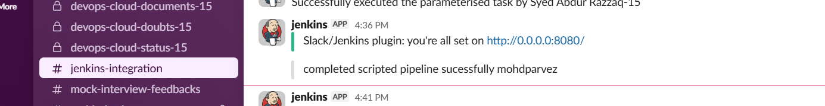

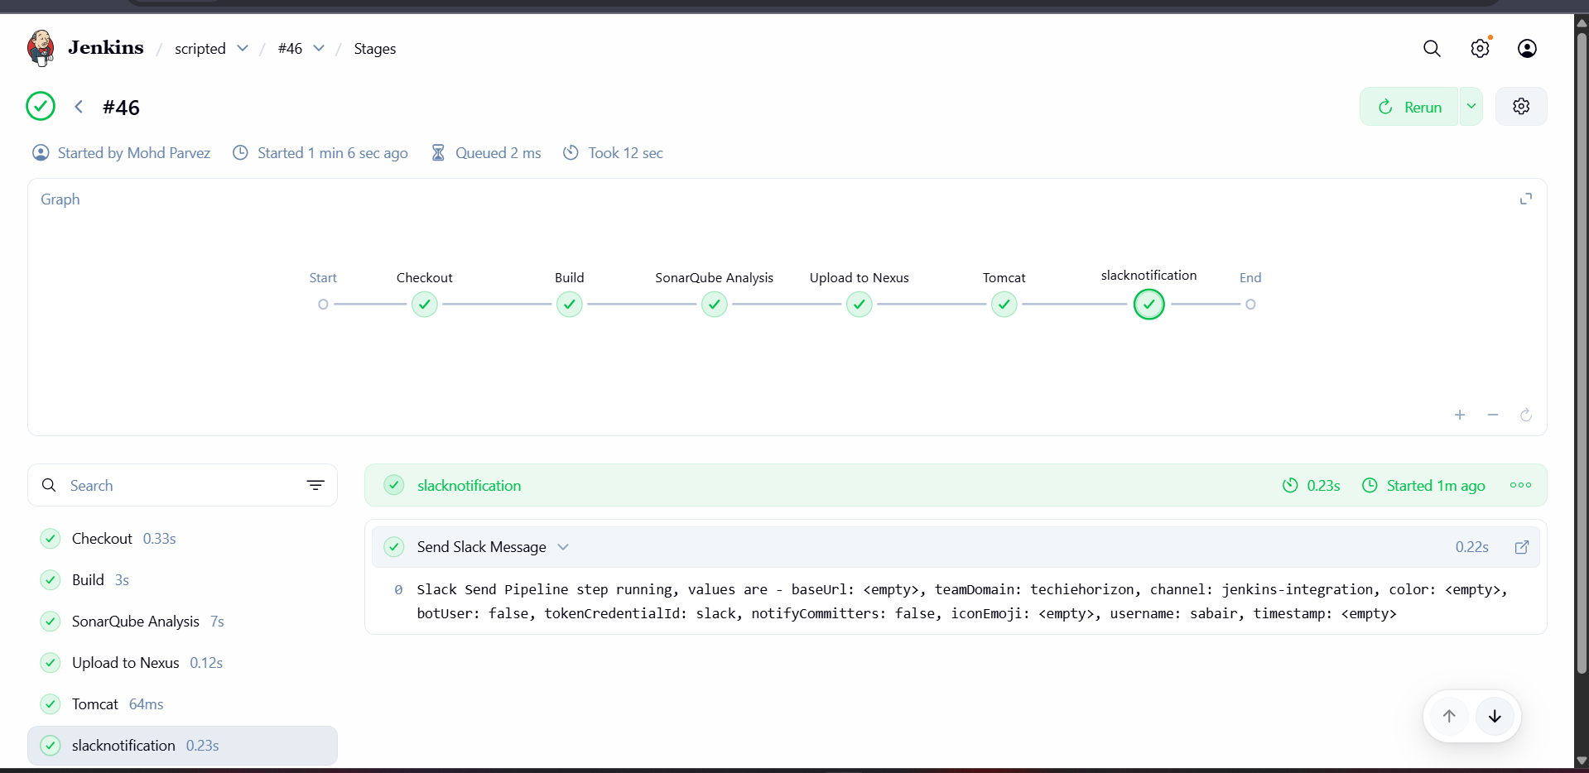

PARAMETERIZED PIPELINE
Create a parameterized job in Jenkins. https://github.com/betawins/spring3-mvc-maven-xml-hello-world-1.git

pipeline {
agent any

tools {
maven "MVN_HOME"
}

parameters {
string(name: 'GIT_REPO', defaultValue: 'https://github.com/betawins/sabear_simplecutomerapp.git', description: 'Git repository URL to clone')
string(name: 'SONAR_PROJECT_KEY', defaultValue: 'Ncodeit', description: 'SonarQube project key')
string(name: 'SONAR_PROJECT_NAME', defaultValue: 'Ncodeit', description: 'SonarQube project name')
string(name: 'SONAR_PROJECT_VERSION', defaultValue: '2.0', description: 'SonarQube project version')
string(name: 'NEXUS_URL', defaultValue: '18.221.189.193:8081/', description: 'Nexus server URL')
choice(name: 'NEXUS_VERSION', choices: ['nexus2', 'nexus3'], description: 'Select Nexus version')
choice(name: 'NEXUS_PROTOCOL', choices: ['http', 'https'], description: 'Nexus protocol type')
string(name: 'NEXUS_REPOSITORY', defaultValue: 'sonarqube', description: 'Nexus repository name')
string(name: 'NEXUS_CREDENTIAL_ID', defaultValue: 'nexus_keygen', description: 'Jenkins credential ID for Nexus authentication')
}

environment {
SCANNER_HOME = tool 'sonar_scanner'
}

stages {
stage("Clone Code") {
steps {
script {
git "${params.GIT_REPO}"
}
}
}

stage("Maven Build") {
steps {
script {
sh 'mvn -Dmaven.test.failure.ignore=true clean install'
}
}
}

stage("SonarQube Analysis") {
steps {
withSonarQubeEnv('sonarqube_server') {
sh """
\$SCANNER_HOME/bin/sonar-scanner \
-Dsonar.projectKey=${params.SONAR_PROJECT_KEY} \
-Dsonar.projectName=${params.SONAR_PROJECT_NAME} \
-Dsonar.projectVersion=${params.SONAR_PROJECT_VERSION} \
-Dsonar.sources=\$WORKSPACE/src/ \
-Dsonar.java.binaries=target/classes
"""
}
}
}

stage("Publish to Nexus") {
steps {
script {
def pom = readMavenPom file: "pom.xml"
def filesByGlob = findFiles(glob: "target/*.${pom.packaging}")
def artifactPath = filesByGlob[0].path

if (fileExists(artifactPath)) {
echo "*** Uploading artifact: ${artifactPath}"
nexusArtifactUploader(
nexusVersion: params.NEXUS_VERSION,
protocol: params.NEXUS_PROTOCOL,
nexusUrl: params.NEXUS_URL,
groupId: pom.groupId,
version: pom.version,
repository: params.NEXUS_REPOSITORY,
credentialsId: params.NEXUS_CREDENTIAL_ID,
artifacts: [
[artifactId: pom.artifactId, classifier: '', file: artifactPath, type: pom.packaging],
[artifactId: pom.artifactId, classifier: '', file: "pom.xml", type: "pom"]
]
)
} else {
error "*** File not found: ${artifactPath}"
}
}
}
}
}
}
stage("Tomcat") {
deploy adapters: [tomcat9(alternativeDeploymentContext: '',
credentialsId: 'tomcat',
path: '', url: 'http://13.61.6.206:8080')],
contextPath: null,
war: '**/*.war'
}